Part A
NumPy
Question 1 :
Create a NumPy array containing the integers from 1 to 20. Perform the following operations: 1. Display the array.
2. Find the shape of the array.
3. Find the maximum and minimum values.
4. Calculate the mean and standard deviation.
5. Reshape the array into a 4 × 5 matrix.
6. Display the second row of the matrix.
7. Display the third column of the matrix.

CODE:-
import numpy as np
arr=np.array([2,4,6,8,10,5,1,3,7,9,11,12,13,14,15,16,17,18,19,20])
print("Array:",arr)
print("Shape of an array:",arr.shape)
print("Maximum value in the array:",np.max(arr))
print("Minimum value in the array:",np.min(arr))
matrix=arr.reshape(4,5)
print(matrix)
row_2 = matrix[1]
print("Second Row of an array is:",row_2)
col_3=matrix[:,2]
print("Third column of an array is:",col_3)
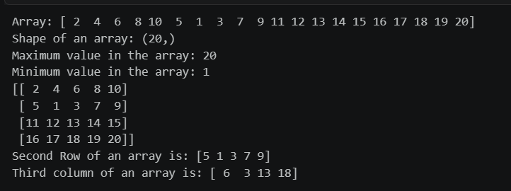
OUTPUT:-
Question 2:
Create two NumPy arrays: A = [10, 20, 30, 40, 50] B = [5, 10, 15, 20, 25] Perform:
1. Addition of A and B.
2. Subtraction of B from A.
3. Element-wise multiplication.
4. Element-wise division.
5. Find the sum of all elements in A.

CODE:-
import numpy as np
A=np.array([10,20,30,40,50])
B=np.array([5,10,15,20,25])
add=np.add(A,B)
print("Addition of A AND B",add)
diff=np.subtract(A,B)
print("SUBTARCTION OF A AND B",diff)
mul=np.multiply(A,B)
print("MULTIPLICATION OF A AND B",mul)
div=np.divide(A,B)
print("DIVISION OF A AND B",div)
sum=np.sum(A)
print("SUM OF ALL ELEMENTS IN A",sum)
OUTPUT:-

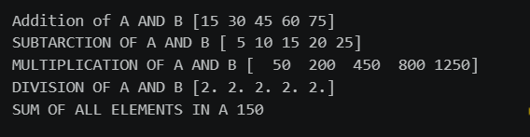

Part B –
Pandas
Question 3 :
Create a DataFrame using the following student data: Roll No Name Marks 101 102 103 104 105 Ravi 85 Priya 92 Kiran 78 Anu 88 Sita 95 Perform the following operations:
1. Display the DataFrame.
2. Display the first three records.
3. Find the average marks.
4. Find the student with the highest marks.
5. Find the student with the lowest marks.
6. Add a new column called "Grade" using:
o A for Marks ≥ 90
o B for Marks between 80 and 89
o C for Marks < 80

CODE:-
import pandas as pd
data = {
"ROLL NO": [101, 102, 103, 104, 105],
"NAME": ["SAI", "KRISHNA", "LIKITH", "TIRU", "NITESH"],
"MARKS": [85, 92, 78, 88, 95]
}
df = pd.DataFrame(data)
print("DataFrame:")
print(df)
print("\nFirst Three Records:")
print(df.head(3))
avg_marks = df["MARKS"].mean()
print("\nAverage Marks:", avg_marks)
highest = df.loc[df["MARKS"].idxmax()]
print("\nStudent with Highest Marks:")
print(highest)
lowest = df.loc[df["MARKS"].idxmin()]
print("\nStudent with Lowest Marks:")
print(lowest)
def grade(mark):
if mark >= 90:
return "A"
elif mark >= 80:
return "B"
else:
return "C"
df["GRADE"] = df["MARKS"].apply(grade)
print("\nDataFrame with Grade:")
print(df)

OUTPUT:-
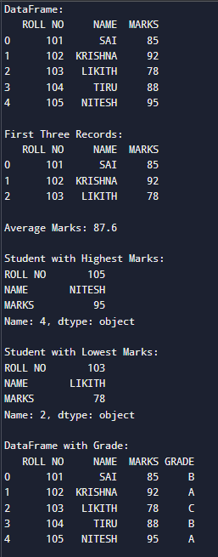

Question 4:
Create a DataFrame containing the following information: Product Price Quantity Laptop 50000 10 Mouse 500 50 Keyboard 1200 30 Monitor 10000 15 Perform:
1. Calculate the total value of each product using: Total Value = Price × Quantity
2. Add the Total Value column.
3. Find the product with the highest total value.
4. Calculate the overall inventory value.

CODE:-
import pandas as pd
data = {
"Product": ["Laptop", "Mouse", "Keyboard", "Monitor"],
"Price": [50000, 500, 1200, 10000],
"Quantity": [10, 50, 30, 15]
}
df = pd.DataFrame(data)
print("Original DataFrame:")
print(df)
df["Total Value"] = df["Price"] * df["Quantity"]
print("\nDataFrame with Total Value:")
print(df)
highest = df.loc[df["Total Value"].idxmax()]
print("\nProduct with Highest Total Value:")
print(highest)
inventory_value = df["Total Value"].sum()
print("\nOverall Inventory Value:", inventory_value)

OUTPUT:-
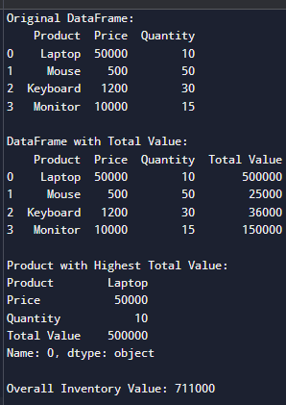

Part C –
Dataset Exploration
Question 5:
Download the Iris dataset from Scikit-learn and perform the following:
1. Load the dataset into a Pandas DataFrame.
2. Display the first five records.
3. Find the number of rows and columns.
4. Display column names.
5. Check for missing values.
6. Generate summary statistics using describe().
7. Find the number of samples belonging to each class.

CODE:-
from sklearn.datasets import load_iris
import pandas as pd
# 1. Load the Iris dataset into a Pandas DataFrame
iris = load_iris()
df = pd.DataFrame(iris.data, columns=iris.feature_names)
# Add target class names
df["species"] = [iris.target_names[i] for i in iris.target]
# 2. Display the first five records
print("First Five Records:")
print(df.head())
# 3. Find the number of rows and columns
print("\nNumber of Rows and Columns:")
print(df.shape)
# 4. Display column names
print("\nColumn Names:")
print(df.columns)
# 5. Check for missing values
print("\nMissing Values:")
print(df.isnull().sum())
# 6. Generate summary statistics
print("\nSummary Statistics:")
print(df.describe())
# 7. Find the number of samples belonging to each class
print("\nSamples in Each Class:")
print(df["species"].value_counts())

OUTPUT:-
